Choice Housing Ireland Ltd
Environmental Policy Statement
Dated: 6th January 2022
Choice Housing Ireland Ltd (Choice) is a voluntary not for profit organisation, which provides and manages quality social and affordable housing, care and support services to meet a wide range of needs.
As a service based organisation we recognise that a number of our activities both directly and indirectly impact upon our environment, such as our use of energy from fossil fuels at our housing schemes and offices.
We have a commitment to fulfil our compliance obligations and other relevant requirements and we are committed to reducing our impact upon the environment, preventing pollution and protecting the environment.
Choice regularly set specific targets on reducing our energy use and our environmental impact, including:
- Reducing energy consumption at our schemes and offices
- Improving the energy efficiency and environmental impact of our existing homes
- Reducing waste and improving recycling facilities available to staff and tenants
To complement these measures we plan to build upon the environmental standards we have achieved in recent years and identify additional environmental objectives, derived from environmental assessments.
Regular checks and reviews will be carried out to ensure there is continual improvement and that our targets are achieved to enhance our environmental performance.
In undertaking continuous environmental improvement we recognise that the need for staff commitment and involvement is crucial, along with the need to work in partnership with our tenants and other interested parties. This Environmental Policy Statement is communicated to all of our employees through our intranet and is also available to the public via our website. It will be reviewed on at least an annual basis.
Review date: 6th January 2023 (or before)
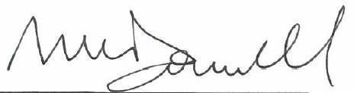
Signature:
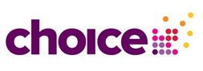
Michael McDonnell, Chief Executive

