**

**Disability Action Plan for Choice Housing Ireland Ltd.**

**2024-2029**

**Disability Action Plan**

**Contents Page**

1. Introduction 3
2. Commitment 3
3. Functions 5
4. Public Life Positions 8
5. Consultation 8
6. Previous Measures 9
7. Action Measures 10
8. **Introduction**

Under Section 49A of the Disability Discrimination Act 1995 (DDA 1995) (as amended by Article 5 of the Disability Discrimination (Northern Ireland) Order 2006), Choice Housing Ireland Ltd (Choice) is required when carrying out its functions to have due regard to the need to:

* promote positive attitudes towards disabled people; and
* encourage participation by disabled people in public life (‘the

disability duties’).

Under Section 49B of the DDA 1995, Choice is also required to submit to the Equality Commission a **disability action plan** showing how it proposes to fulfill these duties in relation to its functions.

1. **Commitment**

As Chair & Group Chief Executive of Choice, we are committed to implementing effectively the disability duties and this disability action plan. We will allocate all necessary resources (in terms of people, time and money) in order to effectively implement this plan and where appropriate, build objectives and targets relating to the disability duties into corporate and annual operating plans.

We will also put appropriate internal arrangements in place to ensure that the disability duties are complied with and this disability action plan is effectively implemented. We will ensure the effective communication of the plan to staff and provide all necessary training and guidance for staff on the disability duties and the implementation of the plan.

We confirm our commitment to submitting an annual report to the Equality Commission on the implementation of this plan as well as carrying out a five yearly review of this plan.

Responsibility for implementing, reviewing and evaluating this disability action plan and the point of contact within Choice will be:

Group Director of Corporate Services

Choice Housing Ireland Ltd.

Leslie Morrell House

37-41 May Street

Belfast

BT1 4DN

Email: enquiries@choice-housing.org

If you require this plan in an alternative format (such as in large print, in Braille, on audio cassette, easy read or on computer disc) and/or language, please contact us on 0300 111 2211 to discuss your requirements.

We confirm our commitment to submitting an annual progress report on the implementation of this plan to the Equality Commission and carrying out a five year review of this plan.

A copy of this plan, our annual progress to the Equality Commission and our five year review of this plan will be made available on our website [www.choice-housing.org](http://www.choice-housing.org)

As part of the operational planning process, Choice will build objectives and targets relating to the disability duties into the annual business planning process. Progress on meeting objectives will be reported to the Association’s Board of Management.

___________________ ___________________

Mr Joe Higgins Mr Michael McDonnell

Chair Group Chief Executive

Date:

1. **Functions**

Choice is one of the largest housing associations in Northern Ireland. The high quality homes, care and support services we provide help meet the diverse needs of a wide range of customers including; older people, families, mature singles and people with complex needs.

Our focus is on delivering more homes, better services and stronger more inclusive communities. We’re proud that more than 10,000 customers have made us their ‘provider of choice’ and we’re committed to building more high quality homes for those who are in need of support.

Our core values commit us to shaping new standards of excellence that redefine our sector and provide more great housing and support at a reasonable cost.

Our Corporate Plan (2021-2024) has been designed to address the following strategic priorities:

Strategic Priority #1

Great Homes – Strategic goals under this priority area encompass:

* To expand our social homes provision, focusing on general needs housing in areas of greatest need;
* To provide and maintain high quality, sustainable and affordable homes;
* To invest in technologies that will contribute to a reduction in Greenhouse gases through ‘pilot projects with a purpose’;
* To promote inclusive, integrated communities through shared housing and mixed tenure developments;
* To maintain a strategic relationship with Oaklee Housing through the Comhar partnership; and
* To meet broader housing need, with excellent wrap-around services and generate a return on investment through Maple & May.

Strategic Priority #2

Great Services - Strategic goals under this priority area, encompass:

• To demonstrate best practice in our health and safety management;

• To ensure that our homes are allocated and re-let in a fair, transparent and timely manner;

• To proactively manage anti-social behaviour and increase tenancy sustainability;

• To provide high quality, value for money response and planned repair services, through Choice Services and external partners;

• To refurbish our existing stock to increase the average EPC rating, thereby improving both affordability and environmental impact;

• To develop an integrated sustainability strategy that targets a net zero carbon ‘footprint’;

• To foster service partnerships that meet diverse customer needs and deliver better outcomes; and

• To promote effective tenant participation so that the tenant voice informs service improvement.

Strategic Priority #3

Great Communities - Strategic goals under this priority area, encompass:

• To be more explicit in our community investment to create and sustain thriving neighbourhoods;

• To expand our community development activities, working with and through others to foster good relations and well-being;

• To support the digital inclusion of tenants, their communities and our partners;

• To raise awareness of the key challenges and opportunities that affect the lives of tenants; and

• To inform and influence public policy and debate around housing supply, housing standards, tenancy management and related services.

Strategic Priority #4

Great Delivery - Strategic goals under this priority area, encompass:

• To be recognized as a high performing, consistently excellent organization by our staff, tenants and partners;

• To demonstrate value for money and good stewardship of our assets and resources;

• To simplify the ‘customer journey’ (both internal and external) through the smart use of technology and continuous improvement;

• To innovate across service areas in an integrated way to improve outcomes for users;

• To make better use of our data to improve decision-making and to demonstrate the benefits that we deliver across society;

• To promote diversity, inclusion and equality of opportunity for all;

• To continue to invest in our people, their skills and talent development; and

• To represent best practice in governance and risk management.

Each of the priorities is underpinned by long-term objectives that will be delivered and monitored through Annual Business Plans, Key Performance Indicators and a Balanced Scorecard.

Choice currently employs over 400 staff. For the purposes of this equality scheme, Choice performs the following functions:

* Provision of a range of housing, care and support services
* Work with partner organisations to deliver support services to people with a physical or mental disability
* Property Maintenance and Repairs
* Refurbishment and remodeling works to maintain housing stock to modern standards
* Development of new homes
* Recruitment of Board and staff
* Contribute to Building Sustainable Communities

Choice is led and controlled by a Board. The Board has ultimate responsibility for directing the activity of the Association, ensuring it is well run and governed, delivering on its social ethos.

*Our Promise*

Our focus is on delivering more great homes, enhanced services and stronger more inclusive communities.

We are a housing association that delivers much more than housing. We are in the business of transforming lives and building communities.

At Choice, we take pride in changing what our customers can expect from a modern housing association. We value our customers as partners in our journey. Personal, friendly and trusted relationships are at the heart of our promise to deliver exceptional services that can anticipate and meet current and future needs.

*Our Core Values*

Our core values are the building blocks of our culture, providing common language and acceptable standards of behaviour. The values we are adopting for our brand and organisational culture are as follows:

• Caring

• Committed

• Creative

***Our Governance Structure as at July 2023***

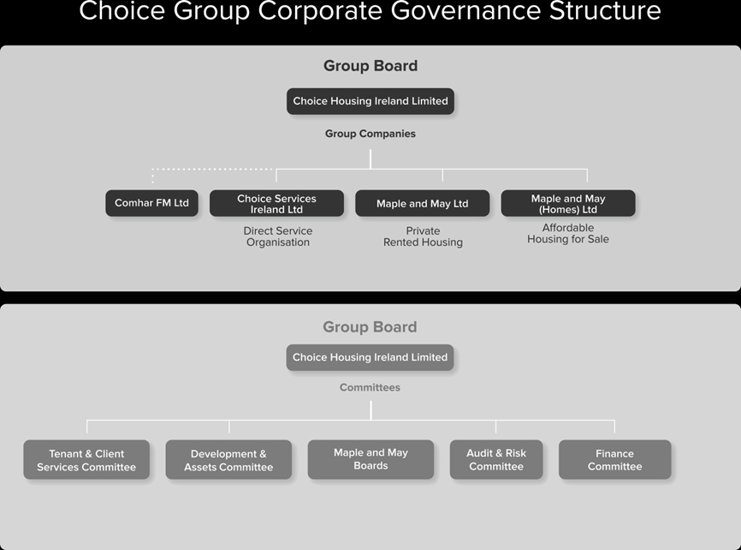

1. **Public Life Positions**

The range of public life positions over which Choice has responsibility for, are as follows:

* *Board Members and Members of Committees*
* *Choice Community Network Members*

1. **Consultation**

Choice is committed to carrying out inclusive and meaningful consultation when developing, implementing and reviewing the Disability Action Plan.

We will consult as widely as possible to ensure that any organisation or group which has a legitimate interest in our work or the likely impact of our policies on people with a disability will be included in the process of engagement.

We are particularly keen to seek the views of disabled people to help us develop and implement the plan.

Through consultation we will seek to:

• Identify barriers faced by disabled people in participating in public life (generally and in relation to their dealings with Choice)

• Identify opportunities for Choice to promote positive attitudes towards disabled people

• Set priorities and identify opportunities for encouraging participation in public life, and

• Assess the effectiveness of actions taken and the proposals outlined in this plan

We particularly welcome comments or feedback on the proposed action measures we plan to take with regard to implementing the disability duties.

1. **Previous Measures**

Outlined below are the key measures that Choice has already taken to promote positive attitudes towards disabled people and to encourage the participation of disabled people in public life.

* Provision of specific accommodation for people with a disability;
* Homes built to Lifetime Homes Standard;
* Adaptations carried out to the homes of tenants with a disability;
* Continue to work with Joint Management Partners to provide affordable, purpose built housing options and deliver effective services which extend across many programmes of care and support including; learning disability, mental ill health, homelessness, addictions, frail elderly as well as Dementia, Autism, children leaving care and mothers with babies;
* Continue to work with NIFHA and lobby stakeholders to retain Supporting People funding;
* Tenants are encouraged to actively engage with Choice and our Tenant Participation Strategy offers a range of methods for people to get involved;
* Positive images of disabled people are included in our publications;
* Policies screened to identify and assess any significant issues relating to the two disability duties;
* Information provided in alternative formats on request;
* Disability Awareness included in staff Inductions; and
* Reasonable Adjustments made for staff / tenants as necessary.

1. **Action Measures**

Outlined below are the measures which we propose to take over the period (*2024-29*) of this Disability Action Plan, together with performance indicators and targets.

Choice is aware of the need to monitor progress in relation to the implementation of the Disability Action Plan to ensure that the duties are being met. The action measures will be reviewed and monitored on an annual basis.

**Measures to promote positive attitudes towards disabled people and encourage the participation of disabled people in public life**

|  |  |  |  |  |  |  |  |
| --- | --- | --- | --- | --- | --- | --- | --- |
| **1.0 Mainstreaming Disability Duties** | | | | | | | |
| **Measures** | | **Responsibility** | | **Target** | | **Performance Indicator** | |
| 1.1 Screen all policies to assess issues in relation to the disabilities duties.  Report findings of screening exercise in Annual Report to the Equality Commission. | | SMT | | Ongoing  31st August each year | | Evidenced in screening reports and Annual Return to the Equality Commission. | |
| 1.2 Monitor delivery of the Disability Action Plan. | | SMT | | Annually | | Progress evidenced in Annual Report to the Equality Commission. | |
| 1.3 Build objectives and targets relating to the disability duties into Corporate and Business Plans. | | SMT | | Annually | | Targets included in Business Plans and progress reported in Annual Report to the Equality Commission. | |
| 1.4 Review and adapt existing monitoring systems to ensure that data relevant to monitoring the effectiveness of the disability duties is collected and utilised. | | SMT | | 2024-29 | | Audit monitoring systems and develop action plan. | |
| 1.5 Carry out adaptation requests as requested by Occupational Therapists. | | Group Director of Assets | | Ongoing | | Adaptations carried out as requested. | |
| **2.0 Mainstreaming Disability Duties** | | | | | | |
| **Measures** | **Responsibility** | | **Target** | | **Performance Indicator** | |
| 2.1 Include requests for statistical information in relation to stakeholders with disabilities in research. | All Deps as relevant | | 2024-29 | | Requests for statistical information included in surveys. | |
| 2.2 Review external and internal communication policies, practices and procedures to assess adverse impact. | Group Director of Corporate Services | | 2024-29 | | All communications policies, practices and procedures take account of disability duties. | |
| 2.3 Monitor requests for publications/information in alternative formats. | All Deps as relevant | | 2024-29 | | Information provided in suitable format as requested in a timely manner. | |
| 2.4 Use the District Housing plans produced by the NIHE to identify specific geographic areas where housing need has been identified for people with disabilities. | Group Director of Development | | 2024-29 | | Housing needs met in areas where it has been identified for people with disabilities. | |
| 2.5 Carry out a formal review of the effectiveness of the Disability Action Plan. | Group Director of Corporate Services | | 2029 | | Formal review of plan to be completed. | |

|  |  |  |  |
| --- | --- | --- | --- |
| **3.0 Disability Duties Training and Disability Awareness Raising** | | | |
| **Measures** | **Responsibility** | **Timescale Indicators/target** | **Performance** |
| 3.1 Provide training on the disability duties and disability awareness to staff and Board and committee members. | Group Director of Corporate Services | 2024-29  Ongoing  Feb 2024 | Training provided to Board and committee members and staff as part of the annual training plan.  Disability duties and awareness included in the induction programme for all staff.  Disability Action Plan available on the intranet. |
| 3.2 Provide specialist training for senior managers, recruitment and selection panels, HR staff and front line staff. | Group Director of Corporate Services | Annual review | Delivered through the annual training plan. |

|  |  |  |  |
| --- | --- | --- | --- |
| **4.0 Promoting Positive Attitudes** | | | |
| **Measures** | **Responsibility** | **Target** | **Performance Indicator** |
| 4.1 Ensure that publications continue to promote positive images of disabled people. | Group Director of Corporate Services | Review annually | Positive imagery used in publications.  Draft articles/comms about portraying positive role models  Include sign language interpreters/subtitles on promotional videos  Use ALT Text on social media posts. |
| 4.2 Work with other organisations who seek to promote positive attitudes towards disabled people. | Group Director of Tenant & Client Services/ Group Director of Corporate Service | Review annually | Progress reviewed annually.  Staff Forum to seek views from disabled staff on how to promote disability equality in the workplace and on policies, practice and procedures. |
| 4.3 Build on partnerships already established with voluntary and statutory organisations providing services for our tenants with complex needs. | Group Director of Tenant & Client Services | Review annually | Progress reviewed annually. |
| 4.4 Work with Joint Management Partners and Contractors/Suppliers to promote positive attitudes towards disabled people. | Group Director of Tenant & Client Services | Review annually | Work with contractors and suppliers on raising awareness of issues and attitudes. |

|  |  |  |  |
| --- | --- | --- | --- |
| **5.0 Encouraging Participation** | | | |
| **Measures** | **Responsibility** | **Target** | **Performance Indicator** |
| 5.1 Ensure inclusive participation for people with a disability on the Board, committees and Community Network. | Chief Executive / Group Director of Tenant & Client Services/Group Director of Corporate Services | Review annually | Join Employers for Disability and advertise vacancies on jobs board.  Review the information sent to applicants to remove any unnecessary barriers to disabled people applying. |
| 5.2 Encourage the participation of disabled people in Tenant Engagement Structure. | Group Director of Tenant & Client Services | Ongoing | Consult with tenants on the preferred methods for engagement. |
| 5.3 Ensure disabled people are encouraged to apply for vacancies. | Group CEO/ Group Director of Tenant & Client Services /Group Director of Corporate Services |  | Review selection criteria and remove unnecessary criteria that could exclude disabled people. Consider introducing a guaranteed interview scheme for shortlisting disabled people who meet the minimum criteria for the position.  Retain a number of board/Network positions where under-representation exists. Ensure applicants can request the support that is available when applying and in post including induction and development opportunities. |
| 5.4 Provide appropriate support to disabled people in any of the Public Life positions. | Group Director of Corporate Services | Ongoing | Support to meet needs identified. |
| 5.5 Effective consultation | Group Director of Corporate Services |  | Consult on action plans by allowing a minimum of two months for the consultation period.  Ensure ongoing dialogue with disabled people/groups regarding the implementation and review of DAPs. |